**11. ReactJS-HOL**

1.Create App

|  |
| --- |
| npx create-react-app eventexamplesapp |

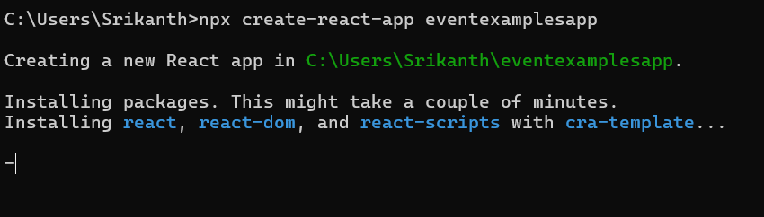

2.Update App.js

|  |
| --- |
| App.js  import React, { Component } from 'react';  import CurrencyConvertor from './CurrencyConvertor';  class App extends Component {    constructor(props) {      super(props);      this.state = {        counter: 1,      };      this.increment = this.increment.bind(this);      this.sayHello = this.sayHello.bind(this);      this.sayWelcome = this.sayWelcome.bind(this);    }    increment() {      this.setState(prev => ({ counter: prev.counter + 1 }));      this.sayHello(); // Static message alert    }    decrement = () => {      this.setState(prev => ({ counter: prev.counter - 1 }));    }    sayHello() {      alert("Hello! Member1");    }    sayWelcome(msg) {      alert(msg);    }    handleClick = (event) => {      alert("I was clicked");      console.log("Synthetic Event:", event);    }    render() {      return (        <div style={{ textAlign: 'left', padding: '20px', fontFamily: 'Arial' }}>          <p>{this.state.counter}</p>          <button onClick={this.increment}>Increment</button><br /><br />          <button onClick={this.decrement}>Decrement</button><br /><br />          <button onClick={() => this.sayWelcome("welcome")}>Say welcome</button><br /><br />          <button onClick={this.handleClick}>Click on me</button><br /><br />          <CurrencyConvertor />        </div>      );    }  }  export default App; |

3.Create CurrencyConvertor Component

|  |
| --- |
| CurrencyConvertor.js  import React, { useState } from 'react';  function CurrencyConvertor() {    const [amount, setAmount] = useState('');    const [currency, setCurrency] = useState('');    const handleSubmit = (e) => {      e.preventDefault();      if (currency.toLowerCase() === 'euro') {        const result = parseFloat(amount) * 80;        alert(`Converting to Euro Amount is ${result}`);      } else {        alert('Please enter valid currency as Euro');      }    };    return (      <div style={{ marginTop: '30px', fontFamily: 'Arial' }}>        <h2 style={{ color: 'green' }}>Currency Convertor!!!</h2>        <form onSubmit={handleSubmit}>          <label>Amount:</label>&nbsp;          <input            type="number"            value={amount}            onChange={(e) => setAmount(e.target.value)}          /><br /><br />          <label>Currency:</label>&nbsp;          <textarea            value={currency}            onChange={(e) => setCurrency(e.target.value)}          /><br /><br />          <button type="submit">Submit</button>        </form>      </div>    );  }  export default CurrencyConvertor; |

**OUTPUT:**

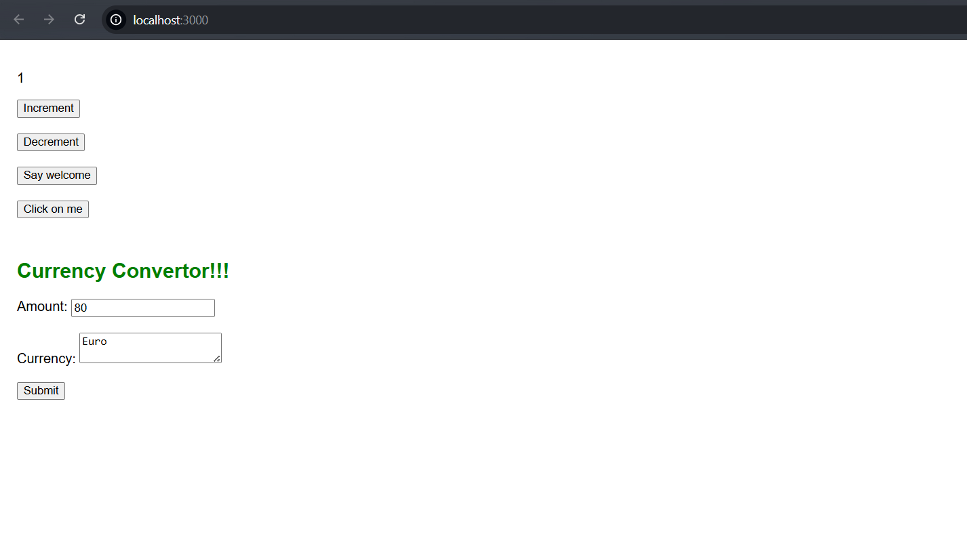

**Increment:**

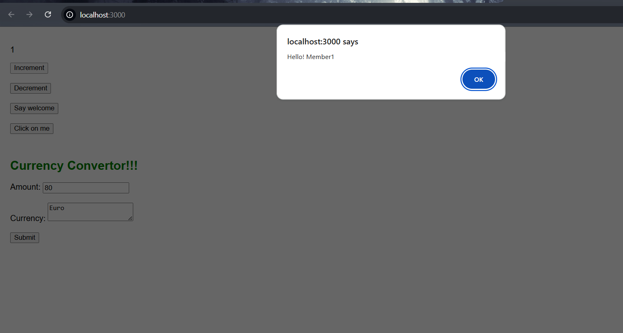

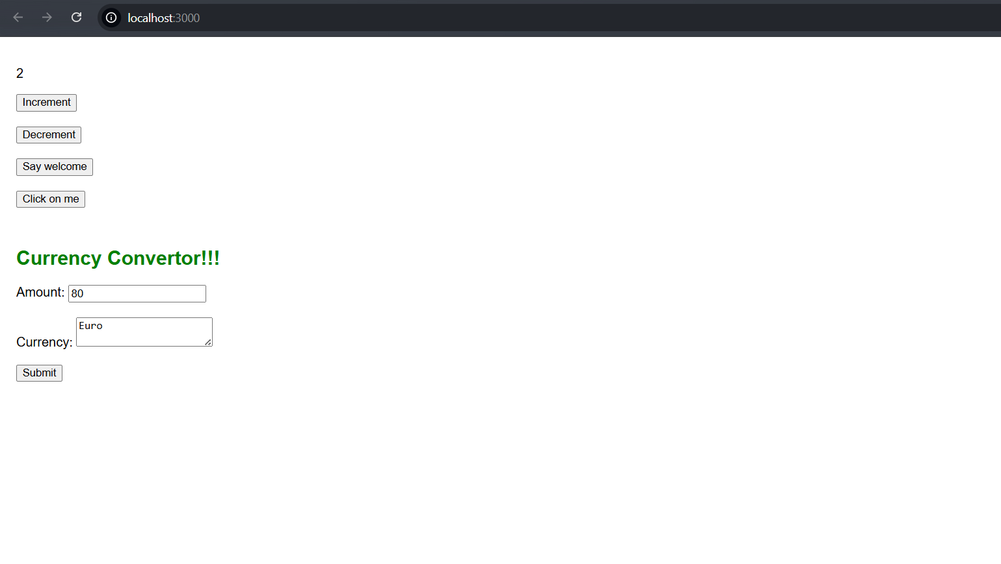

**Decrement:**

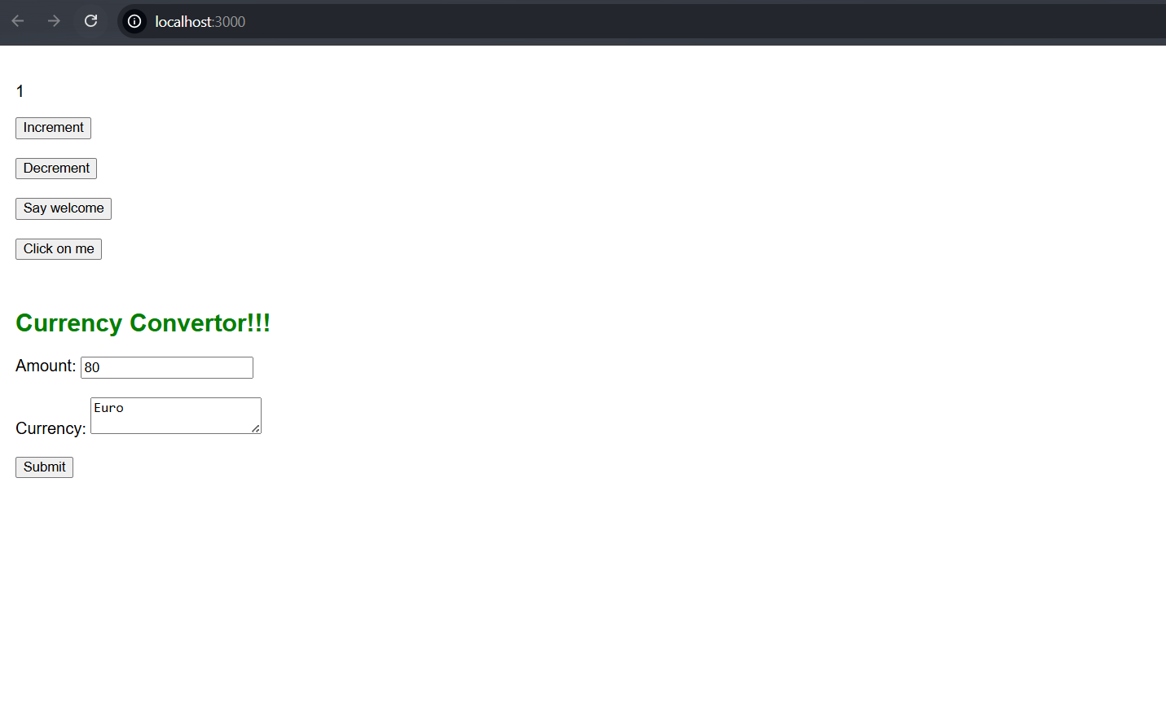

**Say welcome:**

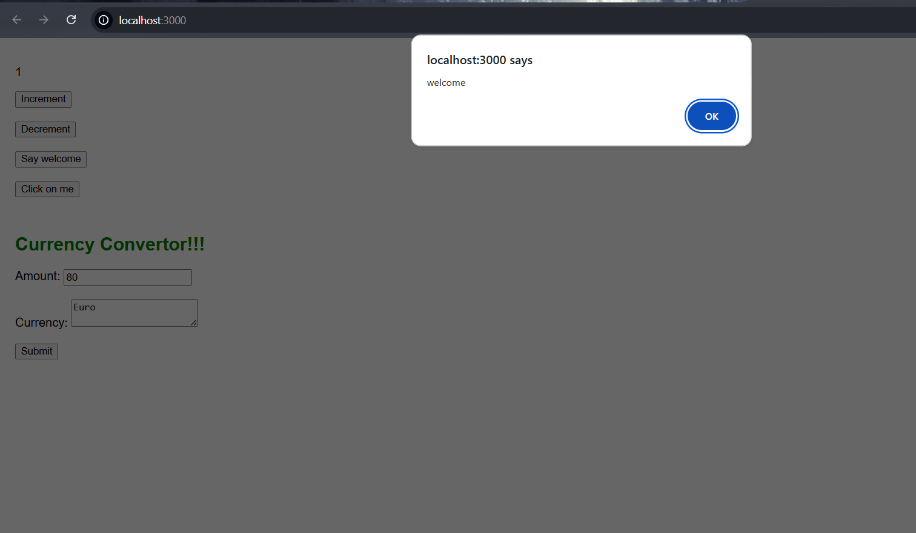

**Click on Me:**

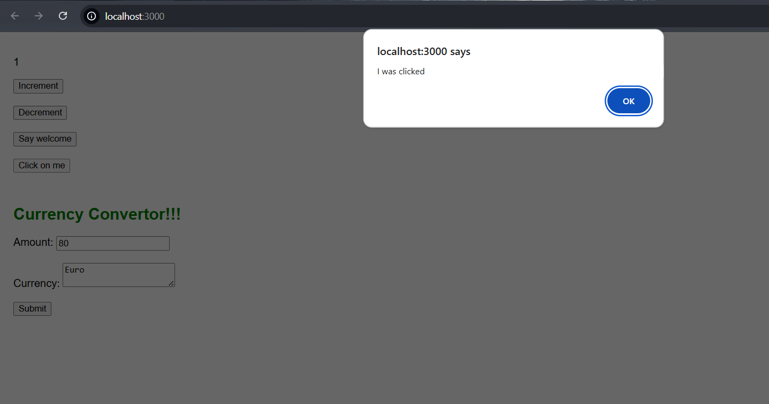

**CurrencyConvertor:**

